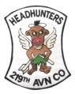
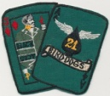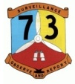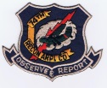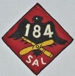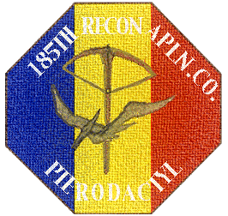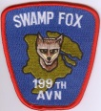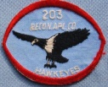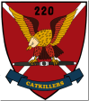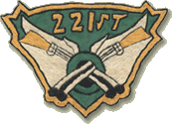
Greetings To All Army Birddog Unit
Vietnam Era Veterans

Your service is already a part of our history. Now you have the opportunity to formally commemorate it.
Through the efforts of volunteers representing all 11 of the units whose insignia are shown above, we have designed a memorial to the Army Birddog aviation companies that served in the Republic of Vietnam. The memorial will be placed in the Ft. Rucker Memorial Park, across from the Army Aviation Museum. This is a private, non-governmental project and has no official connection with, or sponsorship by, the Aviation Museum itself.
Please click on the video below to see just where the Monument will be placed in the park.
http://www.youtube.com/watch?v=DN-UIVMi2Vw
The monument will be made of gray marble with polished black marble plates….12 of them….11 to depict the unit information and the 12th to briefly tell the story of the Army Birddog. We have ordered a bronze Birddog sculpture to be placed on top.
The following url will lead you to monument drawings and plates.
http://www.l19birddog.com/Memorial%20Designs.htm
With your help, we can create a lasting memorial to the men, the units and the aircraft that were such an important part of our lives. The cost of the monument, including installation, including the Birddog sculpture, will be about $36,500. We are confident that the entire amount can be raised through contributions from our unit veterans and friends. There is no minimum contribution and any amount will help. Donations are tax deductible.
Norm MacPhee of the 220th Aviation Company, a retired CPA, will do the accounting and donor record keeping. The Army Aviation Museum Foundation*, Inc. will receive and disburse funds for the monument.
*formed on 9 March 1970 and incorporated under the laws of the State of Alabama as a nonprofit organization
Please print out this page, provide the information requested and return it with your contribution to the address below.
Checks should be made payable to AAMF, Inc. (Army Aviation Museum Foundation, Inc)
Checks should be mailed to: Norm MacPhee
816 W. Francis #502
Spokane, WA 99205

Please provide the following information:
Name: ________________________________________________
Address: ________________________________________________
________________________________________________
Email Address: ________________________________________________
Telephone #: (_____)________________________________
If a veteran, please indicate your unit: _______________________________
If this contribution is in memory of a veteran, please include the name and unit below
Name _____________________________________ Unit _______________________

An Additional Way to Commemorate Your Service
Donors to the memorial may also optionally order an engraved brick “paver”. This paver is a fund-raiser for the Army Aviation Museum Foundation at the Ft. Rucker Museum. You may have three lines engraved on the paver…up to 20 characters per line. The paver will be embedded in the earth around the memorial.
Example of engraving: CW2 Norm MacPhee
220th Catkillers
DaNang – 66-67

Each paver costs $125. The paver order form follows.
IMPORTANT NOTE: Please DO NOT include the cost of a paver in your donation check to the memorial – you must write a second check for the paver and enclose it with the order form that you will send directly to the AAMF along with the order form.
